3.1 Insert records from 42_District_wise_crimes_committed_against_women_2001_2012.csv into a table

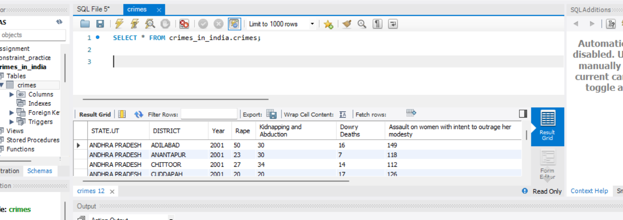

3.2 Write SQL query to find the highest number of rapes & Kidnappings that happened in which state, District, and year

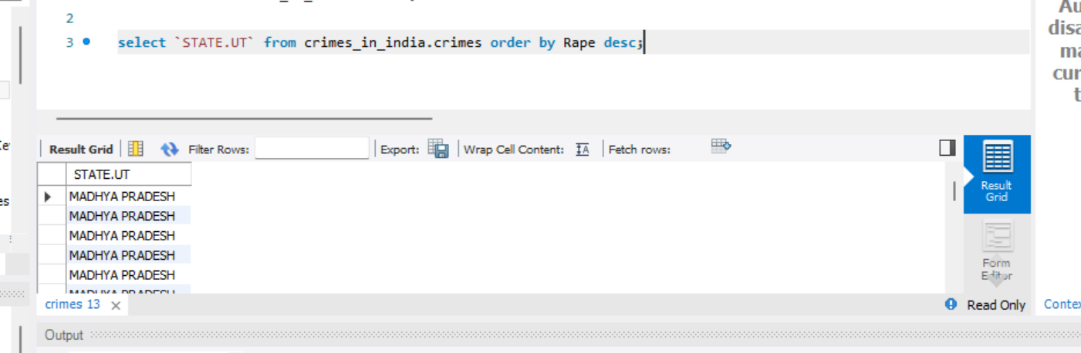

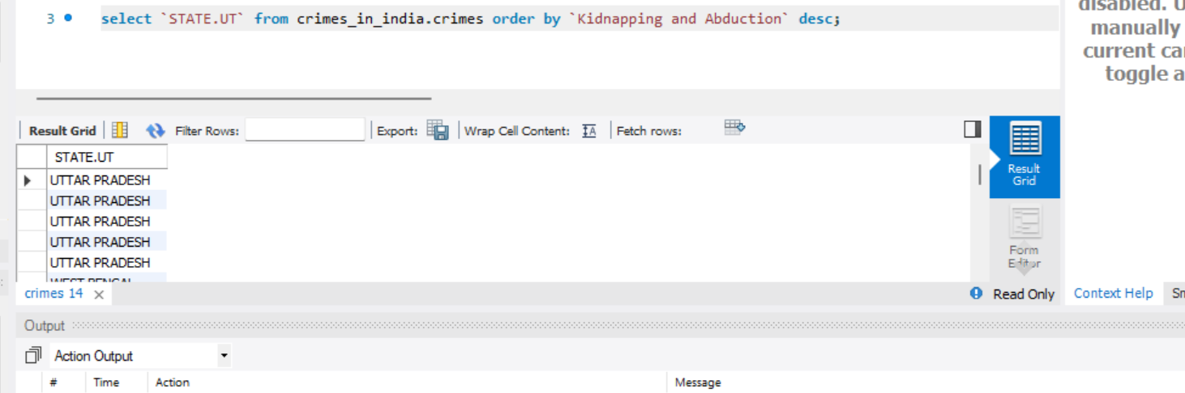

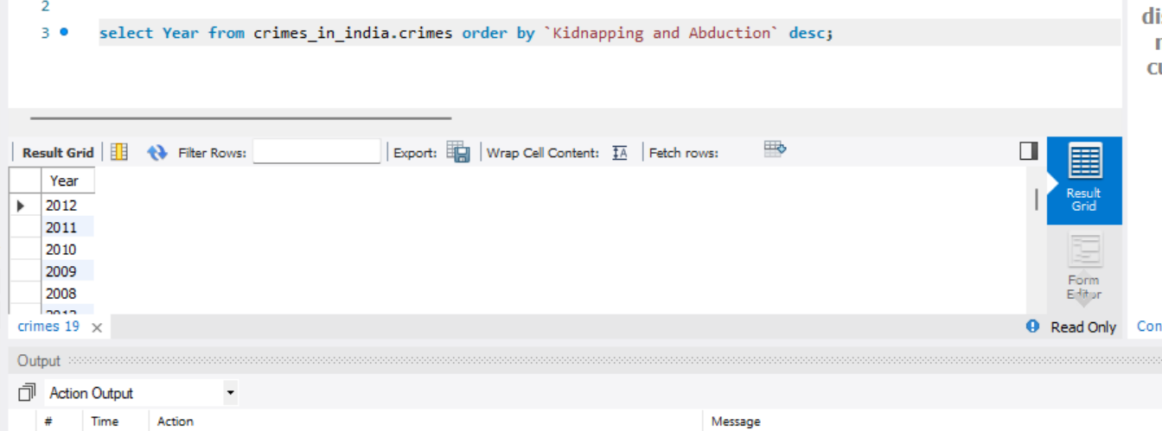

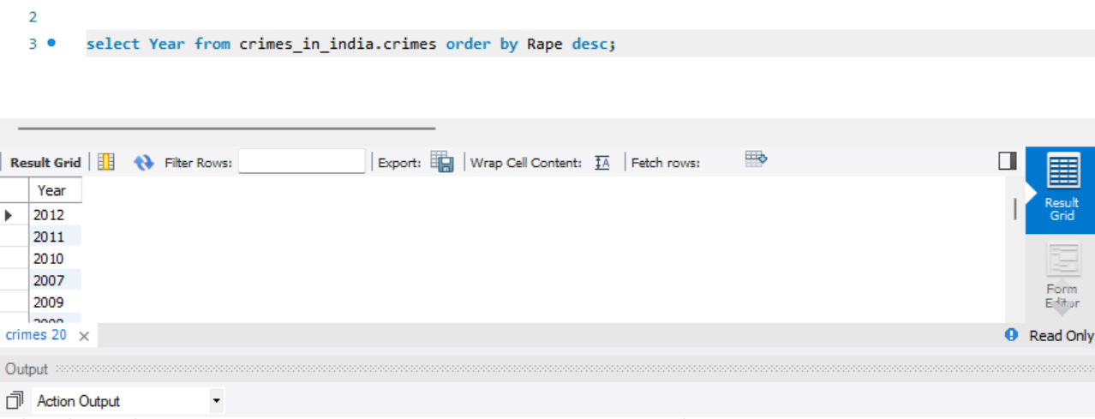

3.3 Write SQL query to find All the lowest number of rapes & Kidnappings that happened in which state, District, and year

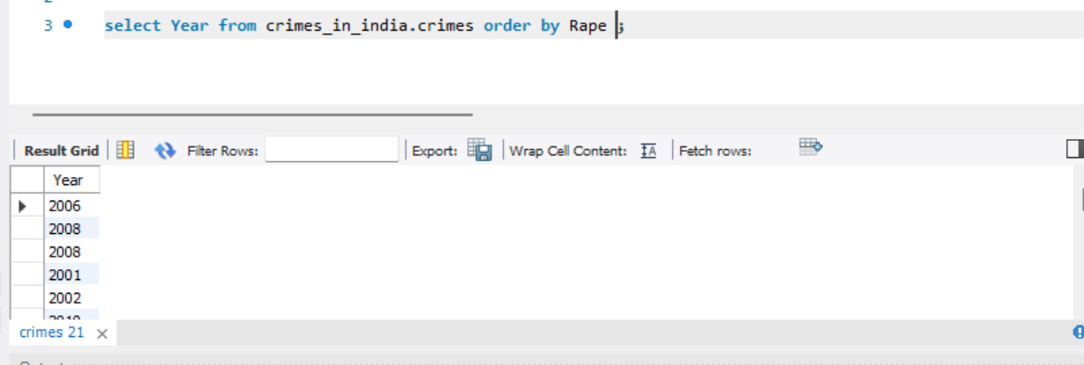

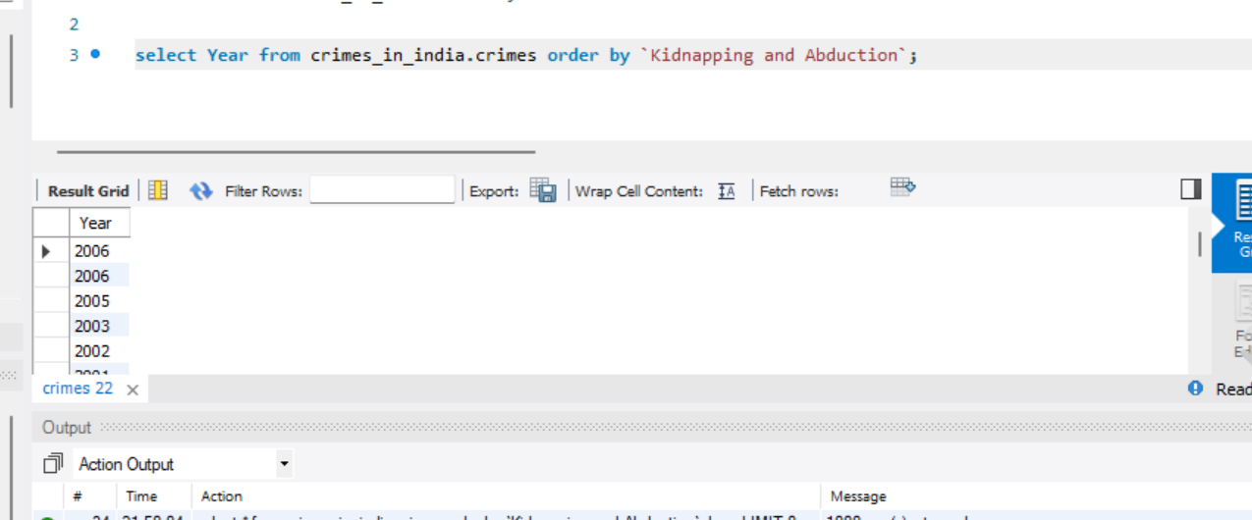

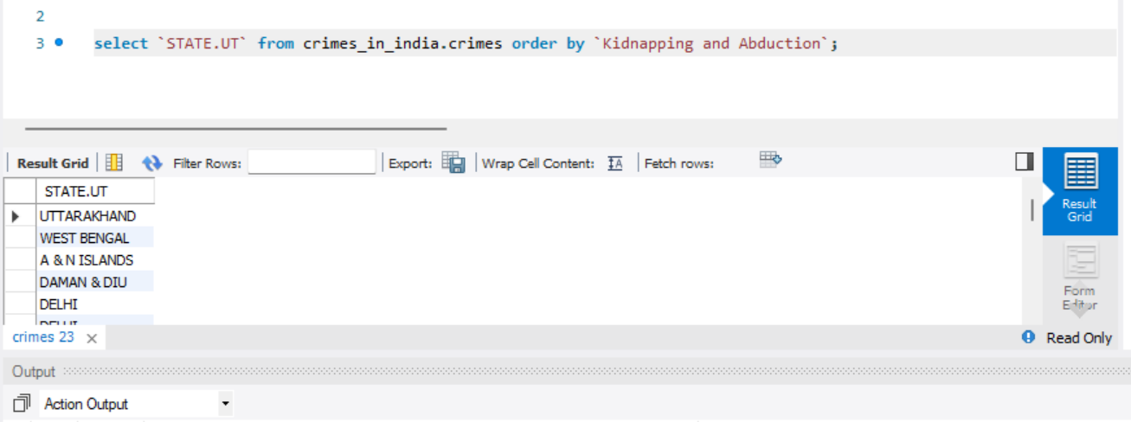

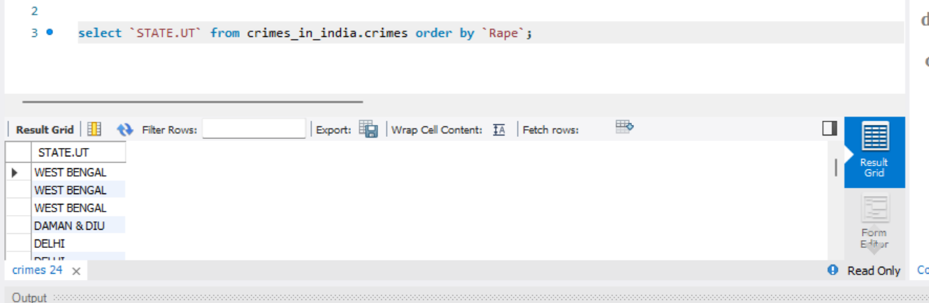

3.4 Insert records from 02_District_wise_crimes_committed_against_ST_2001_2012.csv into a new table

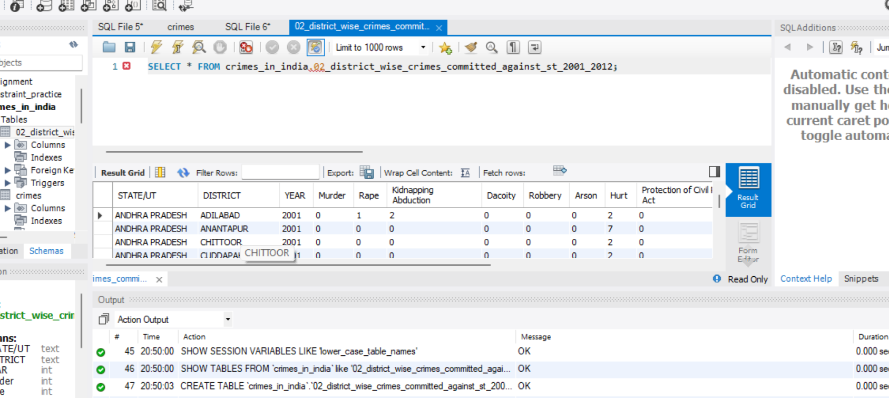

3.5 Write SQL query to find the highest number of dacoity/robbery in which district.

